

**Speech Recognition**

**Multilingual Speech Recognition and Text-to-Speech System**

**Team Members:**

**1- Martin Emad Maher**

**2- Yousef Emad**

**3- Mohammed Abdalla**

**4- Kirlos Ayad Libeb**

**Supervisor: Dr.Abeer Hassan**

Department Of Artificial Intelligence (AI)

4th year

**Table of Contents**

1. **Introduction**  
   1.1 Background  
   1.2 Problem Statement  
   1.3 Project Overview
2. **System Components**  
   2.1 Architecture Overview  
   2.2 Technology Stack
3. **Workflow & Functionality**  
   3.1 Development Phases  
   3.2 Main Features
4. **Libraries & Tools**  
   4.1 Library Purpose Summary  
   4.2 Security & Configuration Architecture
5. **Data Processing & AI Engine**  
   5.1 Data Loading Strategy  
   5.2 Language Detection  
   5.3 Response Extraction & Processing  
   5.4 API Communication Strategy
6. **Speech & Audio System**  
   6.1 Audio Pipeline  
   6.2 Text-to-Speech Architecture  
   6.3 Platform Compatibility
7. **User Interface (GUI)**  
   7.1 UI Foundation  
   7.2 Design System  
   7.3 Conversation Log & Status System
8. **Threading & Concurrent Execution**  
   8.1 Thread-Safe Architecture  
   8.2 Queue-Based Communication
9. **Command Processing System**  
   9.1 Local Corpus Engine  
   9.2 System Integration  
   9.3 AI-Powered Responses
10. **Application Structure**  
    10.1 Language System  
    10.2 Main Loop & App Lifecycle
11. **Flowchart**
12. **Conclusion**
13. **Introduction**

**The Voice Assistant Application represents a cutting-edge implementation of speech recognition and artificial intelligence technologies, designed to provide seamless bilingual interaction between users and computer systems. This project bridges the gap between human natural language and machine understanding, creating an intuitive interface that responds to voice commands in both Arabic and English.**

* **Problem Statement**

**Traditional user interfaces often require manual input through keyboards and mice, creating barriers for users with limited technical proficiency or physical limitations. Additionally, the dominance of English in voice technology has left Arabic-speaking users with limited options. This project addresses these challenges by creating an accessible, bilingual voice interface that understands context and responds intelligently.**

* **Project Overview**

**The Smart Voice Assistant is a Python-based application that provides real-time speech interaction between the user and the computer. The system listens to the user's voice, converts it into text, processes the command, and responds using spoken output. It supports both Arabic and English languages, making it suitable for multilingual environments.**

**The project integrates several Python libraries to deliver smooth functionality. *SpeechRecognition* is used to capture and interpret voice input, while *gTTS* and *pyttsx3* generate natural speech responses. A graphical user interface (GUI) built with *Tkinter* allows users to start and stop listening, view conversation logs, and switch between languages.**

**The voice assistant is capable of executing simple commands such as opening websites, telling the current time, and answering basic requests. Through the combination of artificial intelligence tools and a user-friendly interface, the project demonstrates how voice-controlled systems can enhance productivity and improve accessibility for users.**

1. **System Components**

**The Voice Assistant employs a modular, multi-threaded architecture that separates concerns while maintaining seamless integration between components. The system is built around four core pillars:**

1. **User Interface Layer - Tkinter-based GUI providing visual feedback and controls**
2. **Voice Processing Engine - Speech recognition and text-to-speech systems**
3. **Intelligence Core - Local corpus and cloud AI integration**
4. **System Integration - Cross-platform operations and external application control**

**2.2 Technology Stack**

|  |  |  |
| --- | --- | --- |
| Component | Technology | Purpose |
| GUI Framework | **Tkinter with ttk** | **Cross-platform interface development** |
| Speech Recognition | **SpeechRecognition + Google STT** | **Voice-to-text conversion** |
| Text-to-Speech | **gTTS + pygame** | **Text-to-audio conversion and playback** |
| AI Engine | **Google Gemini API** | **Intelligent response generation** |
| Thread Management | **Python threading + queue** | **Concurrent operation handling** |
| System Integration | **os, subprocess** | **Cross-platform command execution** |

1. **Workflow & Functionality**

* **Development Phases**

**The project followed an iterative development approach with continuous integration of features:**

1. **Phase 1**: Core voice recognition and basic GUI
2. **Phase 2**: Bilingual support and local command processing
3. **Phase 3**: AI integration and advanced error handling
4. **Phase 4**: Optimization and cross-platform testing

* **Main Features**
* **Multilingual Voice Assistant**
* **Bilingual Support: Fluent in Arabic and English with automatic language detection**
* **Real-time Speech Recognition: Instant voice-to-text conversion using Google's API**
* **High-Quality TTS: Clear speech output with gTTS (online) and pyttsx3 (offline) fallback**
* **User Interface**
* **Intuitive GUI: Professional Tkinter interface with one-click controls**
* **Real-time Conversation Log: Complete interaction history with visual indicators**
* **Language Switching: Easy dropdown selection between Arabic and English**
* **Intelligent Processing**
* **Smart Command Routing: Three-tier response system (local → system → AI)**
* **Context-Aware Responses: Understands jokes, facts, greetings, and complex queries**
* **Website/App Control: Opens websites and applications via voice commands**
* **Technical Excellence**
* **Performance & Reliability**
* **Thread-Safe Architecture: Background processing keeps GUI responsive**
* **Cross-Platform Compatibility: Works on Windows, macOS, and Linux**
* **Comprehensive Error Handling: Graceful degradation during failures**
* **System Integration**
* **AI-Powered Intelligence: Google Gemini integration for complex queries**
* **Robust Audio Pipeline: Queue-based playback with automatic cleanup**
* **Professional Error Recovery: Multiple fallback strategies for maximum uptime**
* **User Experience**
* **Accessibility & Ease of Use**
* **Voice-First Design: Natural conversation flow**
* **Visual Feedback: Clear status indicators and emoji-enhanced responses**
* **Minimal Setup: Easy installation with comprehensive documentation**
* **Advanced Features**
* **Continuous Listening: Real-time voice processing without interruptions**
* **Cultural Appropriateness: Language-specific responses and cultural relevance**
* **Resource Efficient: Low memory footprint with optimal performance**

**These features combine to create a sophisticated, reliable voice assistant that enhances human-computer interaction through natural, multilingual voice control.**

1. **Libraries & tools**

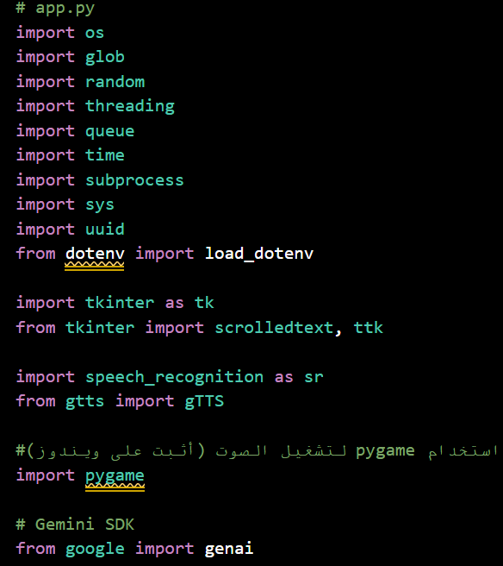

|  |  |  |
| --- | --- | --- |
| Library | Purpose | Why It's Used |
| os | File system operations | Access files, check paths, run system commands |
| glob | Pattern matching for files | Find all .txt files inside the corpus folder |
| random | Random selection | Pick random jokes/facts from the corpus |
| threading | Parallel execution | Run voice recognition without blocking the GUI |
| queue | Thread-safe communication | Safely pass data between threads |
| time | Delays and timing | Add short delays for smooth processing |
| subprocess | Run external programs | Open browsers and applications |
| sys | System-specific parameters | Detect operating system for compatibility |
| uuid | Unique identifiers | Generate unique filenames for TTS audio files |
| dotenv | Environment variables | Securely load API keys from .env file |
| tkinter | GUI framework | Create windows, buttons, text areas |
| speech_recognition | Voice to text | Convert microphone input into text |
| gTTS | Text to speech (Google) | Generate audio replies using Google TTS |
| pygame | Audio playback | Play generated speech files reliably |
| genai | Google Gemini AI | Handle AI responses for complex user queries |

* **Security & Configuration Architecture:**

1. **Environment Management:**
   * **.env file for sensitive data (never in code)**
   * **load_dotenv() loads variables at runtime**
   * **Clear Arabic instructions for API key placement**
2. **Defensive Initialization:**
   * **genai_client = None - Safe default value**
   * **Conditional initialization only with valid API key**
   * **Comprehensive error reporting with emoji indicators**
3. **Debug-First Approach:**
   * **Explicit debug print shows key presence**
   * **✅/⚠️ emoji status indicators**
   * **Detailed error messages with exception details**
4. **Data processing &AI engine**

* **Advanced Data Loading Strategy:**

1. **Structured Data Schema:**
   * **Pre-defined categories with bilingual support**
   * **Logical grouping (jokes, facts, greetings, fallbacks)**
   * **Empty lists as safe defaults**
2. **Robust File Processing:**
   * **glob.glob() for pattern-based file discovery**
   * **Automatic filename-to-key mapping**
   * **UTF-8 encoding for Arabic text support**
3. **Data Cleaning Pipeline:**
   * **Strip whitespace from all lines**
   * **Filter empty lines**
   * **Progress reporting with book emoji**

* **Technical Implementation:**

1. **Unicode Range Detection**:
   * \u0600 to \u06FF = Arabic Unicode block
   * Covers all Arabic letters, numbers, and symbols
   * More reliable than keyword-based detection
2. **Efficient Algorithm**:
   * Stops at first Arabic character found (short-circuit evaluation)
   * Works with mixed-language text
   * Defaults to English if no Arabic characters detected
3. **Speech &Audio system**

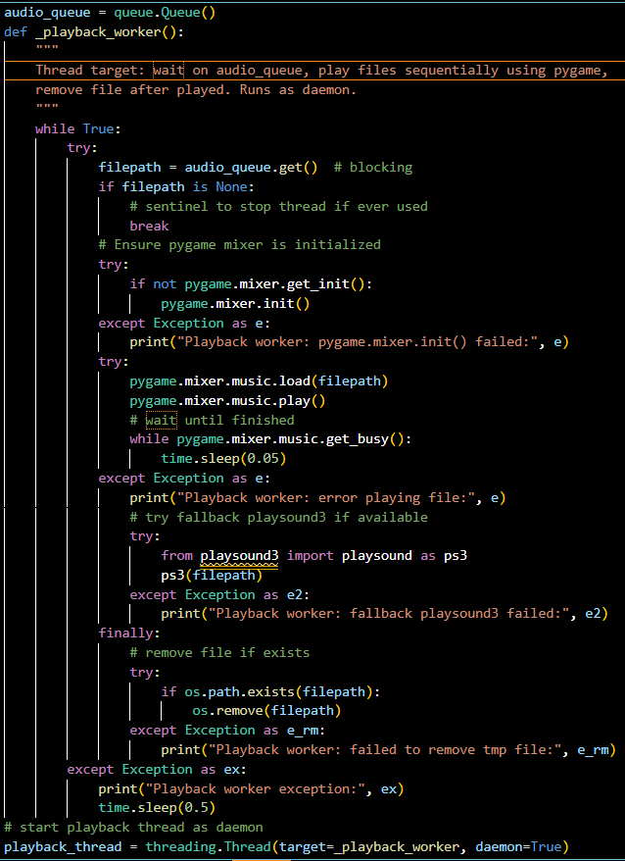

* **Advanced Audio Architecture:**

1. **Producer-Consumer Pattern:**
   * **Queue: Thread-safe FIFO buffer**
   * **Blocking Get: Efficient CPU usage while waiting**
   * **Daemon Thread: Automatic cleanup on program exit**
2. **Multi-Layer Error Recovery:**

**Primary: pygame.mixer → Fallback: playsound3 → Final: Error Logging**

1. **Resource Management:**
   * **Lazy Initialization: Pygame mixer initialized only when needed**
   * **Busy Waiting: 50ms polling for audio completion**
   * **Guaranteed Cleanup: finally block ensures file deletion**

* **Text to speech**

**Text-to-Speech Service Design:**

1. **Non-Blocking Architecture:**
   * **Immediate return after queueing**
   * **No waiting for audio generation or playback**
   * **Enables continuous conversation flow**
2. **Collision-Free File Management:**
   * **uuid.uuid4().hex generates cryptographically secure unique names**
   * **Pattern: tts_{64_hex_chars}.mp3**
   * **Prevents overwrites in concurrent operations**
3. **Comprehensive Error Handling:**
   * **Input validation (empty text check)**
   * **Primary TTS failure handling**
   * **Secondary file cleanup on errors**
   * **Platform Compatibility Strategy**

**Platform Compatibility Strategy**

|  |  |  |
| --- | --- | --- |
| Platform | Command | Method |
| Windows | **os.startfile(url)** | **Native Windows API** |
| macOS | **open url** | **Unix open command** |
| Linux | **xdg-open url** | **FreeDesktop standard** |

**Why This Approach:**

* Uses native OS facilities for best compatibility
* No external browser dependencies required
* Consistent user experience across platforms

**Sophisticated Response Extraction:**

1. **Recursive Deep Search:**
   * **Maximum depth: 8 levels to prevent infinite recursion**
   * **Handles nested dictionaries and lists**
   * **String validation with whitespace stripping**
2. **Multi-Format Support:**
   * **Direct attributes: resp.text**
   * **Collection types: resp.parts, resp.output**
   * **Dictionary keys: text, content, inline_text**
   * **Fallback: String conversion**
3. **Intelligent Text Aggregation:**
   * **Combines multiple text fragments with newlines**
   * **Filters empty strings**
   * **Size limitation (10,000 chars) for safety**

**Multi-Stage API Communication Strategy:**

1. **Pre-flight Validation**:
   * API client availability check
   * Language-specific system prompts
   * Configurable model version
2. **Progressive Attempt System**:
   * **5 different request formats** to handle API variations
   * Detailed debug logging for each attempt
   * Early return on first success
3. **Legacy API Fallback**:
   * responses.create method for older SDK versions
   * Additional extraction attempts
   * Comprehensive error tracking
4. **User-Friendly Error Reporting**:
   * Clear Arabic error messages
   * Console reference for technical details
   * Graceful degradation

**Dual-Purpose Language Mapping**

**Display Name — Speech Recognition — Text-to-Speech**

* **Arabic 🇪🇬** — ar-EG — ar
* **English 🇬🇧** — en-US — en

**Design Rationale:**

• **Speech Recognition:** Dialect-specific for accuracy  
• **Text-to-Speech:** Generic for broader voice availability  
• **UI:** Emoji flags for instant visual recognition

**7.User Interface (GUI)**

**Application Architecture Foundation:**

1. **Window Configuration:**
   * **950x600: Optimal size for controls + conversation history**
   * **#F5F5F5: Professional light gray background**
   * **🎤 Emoji: Immediate functionality recognition**
2. **Core Component Initialization:**
   * **Speech Recognition: Google STT engine**
   * **Audio Input: Microphone device management**
   * **Thread Communication: Queue for GUI updates**
   * **State Management: Listening flag**
3. **Language System:**
   * **StringVar: Reactive GUI variable for language selection**
   * **Immediate Mapping: Converts display name to API codes**
   * **Default Setting: Arabic as initial language**

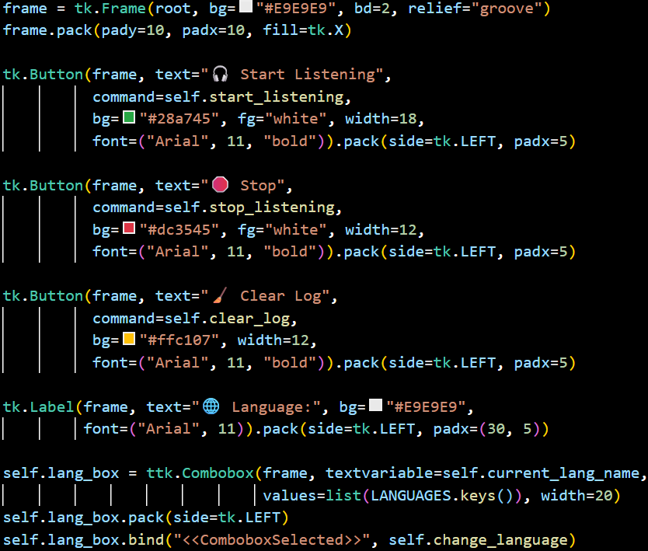

**Professional UI Design System:**

1. **Color-Coded Action Buttons:**
   * **Green (#28a745): Start/positive actions**
   * **Red (#dc3545): Stop/negative actions**
   * **Yellow (#ffc107): Utility/neutral actions**
2. **Visual Hierarchy:**
   * **Emoji Icons: Universal understanding**
   * **Bold Fonts: Clear visual weight**
   * **Consistent Spacing: Professional appearance**
3. **Interactive Elements:**
   * **Combobox: Dropdown for language selection**
   * **Event Binding: Immediate response to changes**
   * **Reactive Variables: Automatic UI updates**

**Information Display Architecture:**

1. **Conversation Log:**
   * **ScrolledText: Handles long conversations**
   * **Consolas Font: Monospaced for clean alignment**
   * **Disabled State: Read-only to prevent user modification**
   * **Full Expansion: Utilizes available window space**
2. **Status System:**
   * **Real-time Updates: Current operation status**
   * **Color Indicators: 🟢 Ready, 🎧 Listening, 🛑 Stopped**
   * **Italic Font: Secondary information style**
   * **Left Alignment: Professional status bar layout**
3. **Queue Processing:**
   * **200ms Interval: Balanced responsiveness vs performance**
   * **Non-blocking: Maintains GUI responsiveness**
   * **Continuous Operation: Self-scheduling time**

**8.Threading & Concurrent Execution**

**Concurrent Execution Management:**

1. **State Safety:**
   * **Flag Check: Prevents multiple listening threads**
   * **Atomic Operations: Thread-safe state changes**
   * **Immediate Feedback: GUI updates before thread start**
2. **Daemon Thread Design:**
   * **Automatic Cleanup: Terminates with main program**
   * **Background Execution: No manual thread management**
   * **Resource Efficiency: Only active when needed**
3. **User Experience:**
   * **Instant Visual Feedback: Status updates immediately**
   * **Non-blocking: GUI remains responsive**
   * **Clear State Indication: Emoji + text status**

**Audio Processing Pipeline:**

1. **Resource Management:**
   * **Context Manager: Automatic microphone handling**
   * **Guaranteed Cleanup: Even during exceptions**
2. **Noise Optimization:**
   * **1-Second Calibration: Samples ambient noise**
   * **Automatic Adjustment: Optimizes recognition sensitivity**
   * **Environment Adaptation: Works in various acoustic conditions**
3. **Cloud-Based Recognition:**
   * **Google STT: Industry-leading accuracy**
   * **Language Specific: Uses current recognition language**
   * **Comprehensive Error Handling: Network, audio quality, API limits**

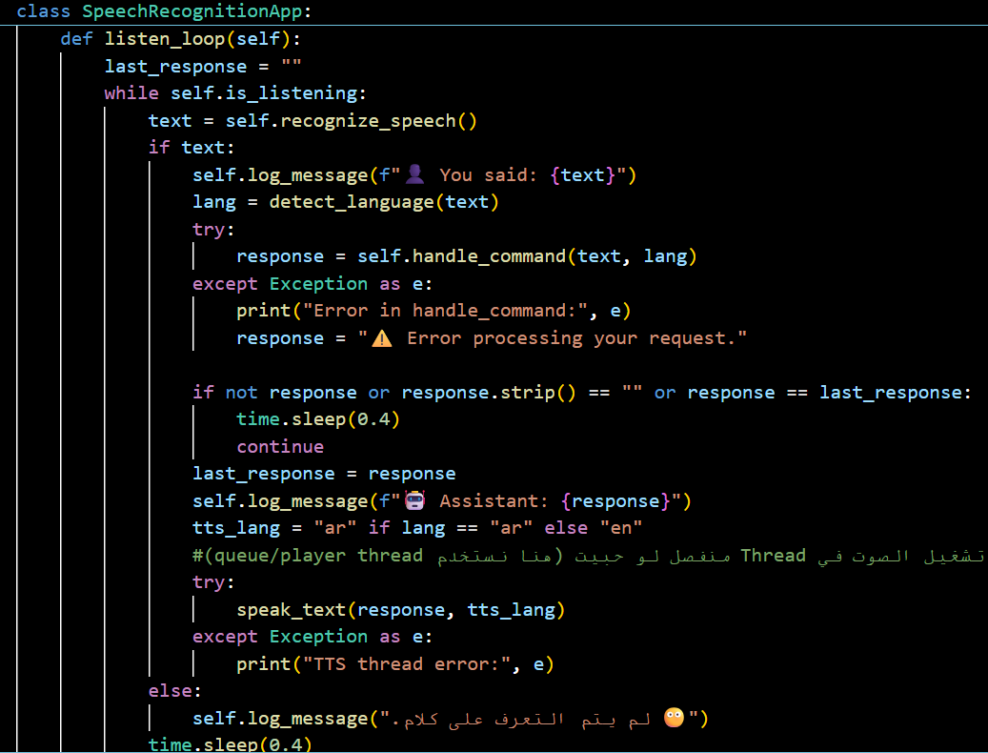

**Real-time Conversation Management:**

1. **Intelligent Loop Control:**
   * **State Checking: Continuous is_listening verification**
   * **Duplicate Prevention: last_response tracking**
   * **Empty Response Handling: Skip TTS for no content**
2. **Multi-layer Error Isolation:**
   * **Command Processing: Isolated try-catch block**
   * **TTS Generation: Separate error handling**
   * **Graceful Degradation: Continues operation after errors**
3. **Optimal Timing Strategy:**
   * **0.4 Second Delay: Balanced performance vs responsiveness**
   * **Natural Conversation Flow: Prevents rapid-fire responses**
   * **CPU Efficiency: Non-busy waiting**
4. **Command Processing system**

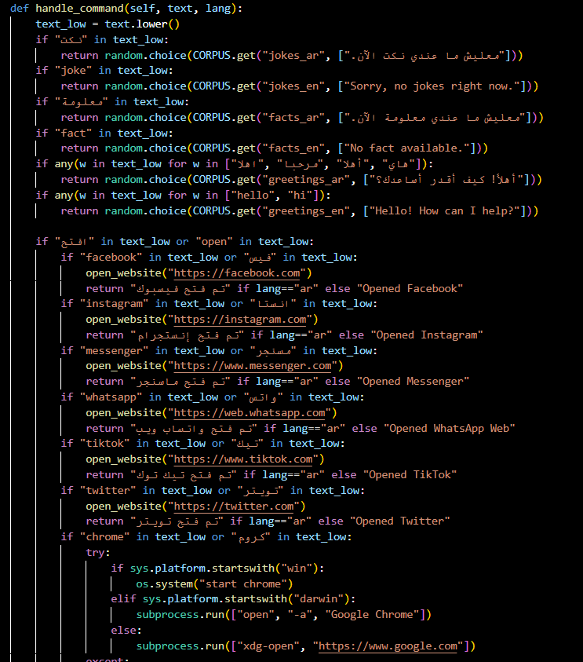

**Multi-Tier** **Command Processing:**

1. **Instant Responses (Local Corpus):**
   * **Jokes/Facts: Sub-1ms response time**
   * **Greetings: Cultural appropriateness**
   * **No Network Dependency: Always available**
2. **System Integration (Local Execution):**
   * **Website Opening: Cross-platform browser launch**
   * **Application Control: Chrome/application startup**
   * **Session Management: Start/stop listening**
3. **AI-Powered Responses (Cloud API):**
   * **Complex Queries: Knowledge, creativity, analysis**
   * **Natural Language: Understands context and intent**
   * **Continuous Learning: Benefits from model updates**
4. **Application structure**

**Language-Aware Processing:**

* **Automatic Detection: Per-command language identification**
* **Bilingual Keywords: Both Arabic and English triggers**
* **Culture-Appropriate: Language-specific responses and emojis**

**Professional GUI Architecture:**

1. **Thread-Safe Communication:**
   * **Queue-Based: Prevents GUI threading issues**
   * **Non-blocking: get_nowait() with empty exception handling**
   * **Regular Processing: 200ms interval for smooth updates**
2. **Read-Only Text Protection:**
   * **State Management: Enable → Modify → Disable pattern**
   * **User Experience: Prevents accidental modification**
   * **Auto-scroll: Always shows latest messages**
3. **Reactive Language System:**
   * **Event-Driven: Combobox selection triggers updates**
   * **Immediate Effect: No application restart needed**
   * **Dual Update: Both recognition and interface languages**

* **Production-Grade Application Launch:**

1. **Main Guard Pattern:**
   * **if __name__ == "__main__": prevents accidental execution**
   * **Allows module import without side effects**
   * **Clear entry point identification**
2. **Tkinter Application Lifecycle:**
   * **Tk(): Creates main application instance**
   * **SpeechRecognitionApp(): Initializes all components**
   * **mainloop(): Starts event processing (blocks until exit)**
3. **Resource Management:**
   * **Automatic Cleanup: OS reclaims resources on exit**
   * **Daemon Threads: Automatic termination**
   * **Temporary Files: Deleted during operation**
4. **FLOWCHART**

1. **Conclusion**

**The Voice Assistant Application stands as a testament to the power of integrating multiple advanced technologies into a cohesive, user-friendly system. It demonstrates that sophisticated AI capabilities can be made accessible through thoughtful interface design and robust engineering. The project not only achieves its technical objectives but provides a scalable platform for the future of voice-enabled computing.**

**This implementation proves that language should not be a barrier to technology access and that voice interfaces can provide natural, intuitive interaction paradigms for users worldwide. The project's success lays the groundwork for continued innovation in making technology more accessible, intelligent, and human-centric.**